Problem 1

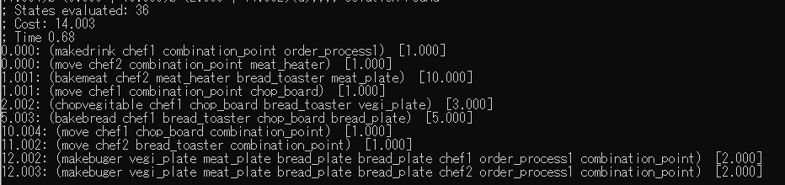

Problem 2

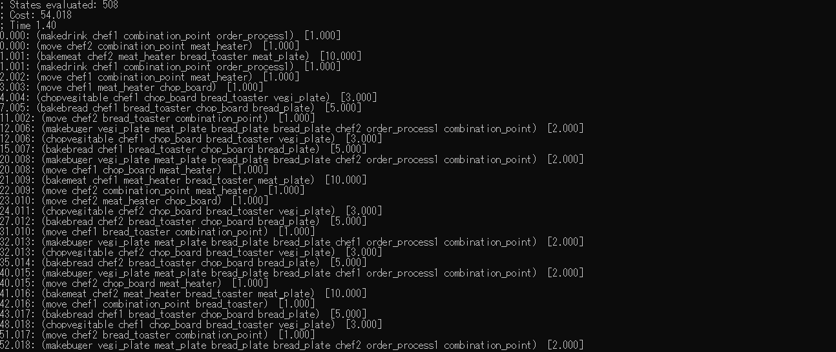

Problem 3

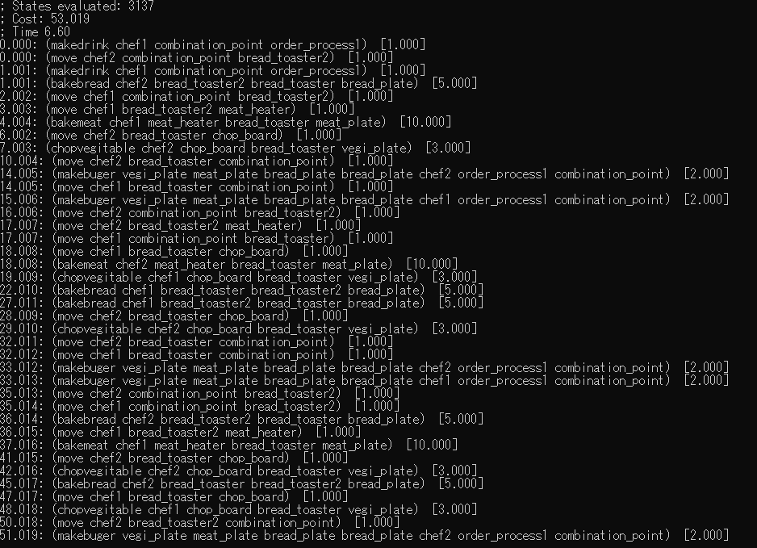

Problem 4

TOO COMPLEX